**Soldering Iron**

|  |  |
| --- | --- |
| Author | Steffen Pousset |

Content

1 Introduction 1

2 Material and methods 2

3 Results 2

3.1 What is a soldering iron 2

3.2 Working principle 3

3.2.1 Subtitle 3

3.2.2 Subtitle 3

4 Discussion 4

5 Reference list 4

# Introduction

The project is about building a DIY soldering iron. This is a fast heating, accurate and cheap solution instead of buying one. This device can heat the soldering iron up to 500°C it is used for precision soldering small components. The soldering iron has been chosen because it is a very useful device is to have in the electronics industry. To make this project, a DIY guide from a YouTuber and datasheets such as that of the Arduino and a heat reading sensor was used. The topics discussed are: the components with their function and price, electric scheme, PCB design and the casing.

# Material and methods

The table below shows the material with the manufacturer, the price and name.



Figure 1: Table of components

The components were chosen because they were in the building plans. The only additional components are those of the Arduino and the temperature reader that is integrated on the circuit board. Some of the components such as the oled screen and clock crystal where hard to get from a manufacturers.

# Results

In this section there will be an explanation about my results of this project.

## What is a soldering iron

A soldering iron is composed of a heated metal tip and an insulated handle. Heating is often achieved electrically, by passing an electric current through a resistive heating element. Simple irons, less commonly used today than in the past, were simply a large copper bit on a handle, heated in a flame.

Solder melts at approximately 185 °C (365 °F). Soldering irons are designed to reach a temperature range of 200 to 480 °C (392 to 896 °F).

Soldering irons are most often used for installation, repairs, and limited production work in electronics assembly. High-volume production lines use other soldering methods. Large irons may be used for soldering joints in sheet metal objects. Less common uses include pyrography and plastic welding.

## Working principle

The figure below shows the electrical diagram which is made in Altium.

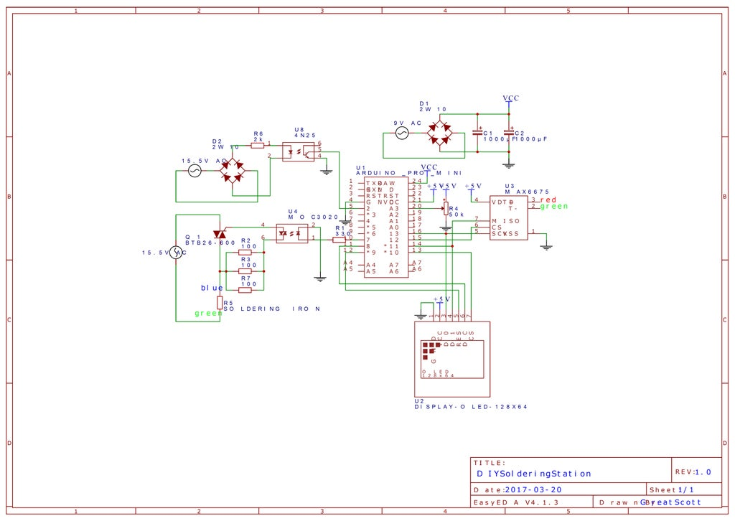

Figure 2: Drawing

First the transformer will change the 230Vac to 16Vac. At that point the rectifier will change the 16Vac over to 16Vdc the optocoupler(u8) will recognize the signal. The Arduino utilizes the signal for controlling the 16Vac power for warming up the soldering iron. A Max6675 is utilized for reading the temperature and the Arduino will convert and send it to the oled display and it will display the temperature of the soldering iron. The potentiometer is used to control the temperature. The other circuit on the top right side is used to power the Arduino because the Arduino needs 7Vds.

### PCB

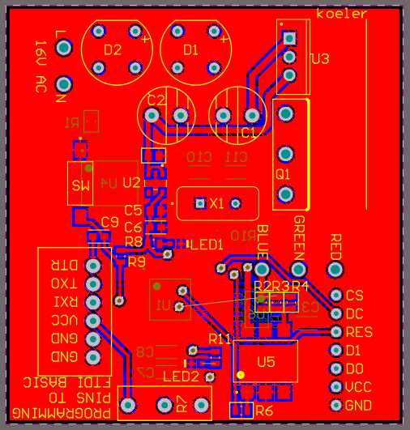

Figure 3: Altium design

After completing the PCB design the next step is to check the link between the parts to ensure the working of the PCB. The PCB file needs to be checked within altium for the footprints and design which needs to be in the same size as the case in Autocad. After creating the design, the PCB was a bit too big which lead into a problem. The PCB didn't have the same height as the design of the case had. After seeing that, the case was updated for a better fit.

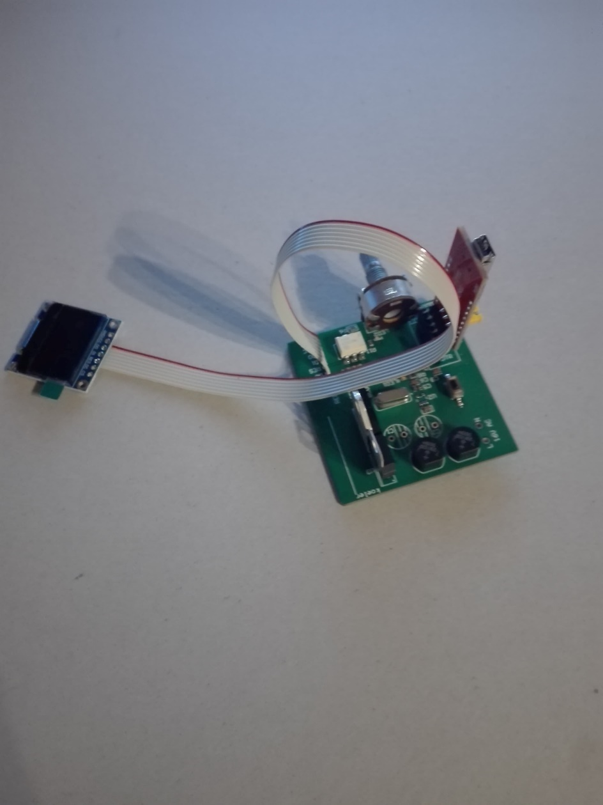

Figure 4: Front of PCB

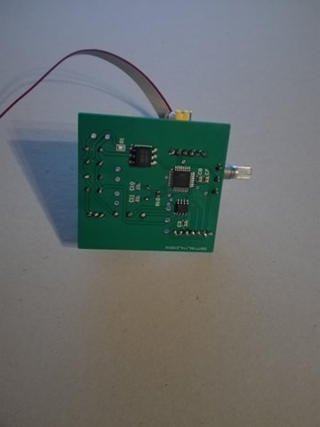

Figure 5: Back of PCB

Those pictures show the PCB in his current state, All the SMD components are placed and solded into the PCB. This is the finalized product which the case will cover.

### Mechanical design

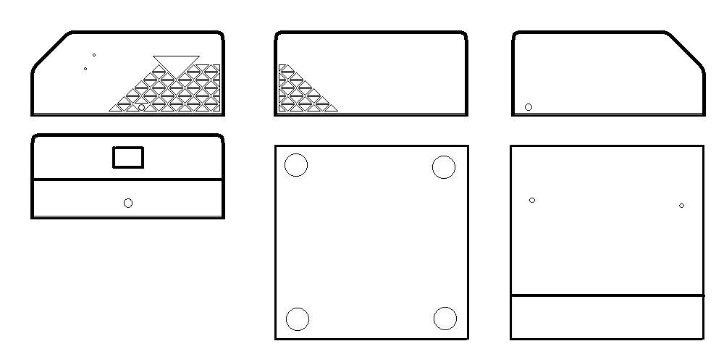

Figure 6: Mechanical design

This mechanical design is constructed to well hold the PCB in his place. This design is made to show of the project in an amazing way which would display it in his original condition. This is created with 6 separated sides which are 1 piece together. It is created in different styles to give the PCB a good support to protect it from any issue or accident which might happen during the use of the product. The design is made in an triangle form to give it a personal look.

# Discussion

The designing of the electrical scheme through Altium went smooth but the components for this project were not in the internal library. The placing and routing of the components were challenging to place because, some components need a specific place. The smaller components also need special attention because they have a small tolerance the thickness of the printed circuits needed to be calculated.

A problem which did occur was the delivery time for each component. Some components did come earlier than expected what meant that I could start, but because of the waiting time of the PCB I did need to wait a week longer. therefor I didn't start my project on time while being sure to start early and complete the project as soon as possible.

Since the project dates from the year 2017, some components such are hard to get via normal manufacturers. When ordering each component, the delivery time needs to be taken into account to avoid that the deadline gets compromised. For components where a clear pinout description is missing, datasheets can offer a solution to find out. This will reduce the chance of incorrect electrical connections.

The design of the PCB housing presented a couple of challenges. It needed a place for a logo it must be compact. There must be a place for the oled screen and buttons. Autocad was a difficult project since this was a new challenge. The design needed to have sharp corners. It was needed to make it look good as in design. Since this could be used daily and should be steady at all times.

Because the project was expensive it would be better if there was a project assigned to every student that is cheaper. A recommendation is to give every student the same project to see how each student develops in his own way.

# List of pictures

Figure 1: Table of components 2

Figure 2: Drawing 3

Figure 3: Altium design 4

Figure 4: Front of PCB 4

Figure 5: Back of PCB 5

Figure 6: Mechanical design 5

# Reference list

[DIY Arduino Soldering Station : 6 Steps (with Pictures) - Instructables](https://www.instructables.com/DIY-Arduino-Soldering-Station/)